P.Lakshmi Vani
192365018
CSA1013

CO3 ASSESSMENT TOOL 1 – GIT & DOCKER TECHNICAL ASSIGNMENT
Smart Cold Storage Monitoring and Food Preservation System
Field | Details | Field | Details
Course Code | CSA10 | Course Title | Software Engineering
CO Assessed | CO3 | Assessment | Assessment Tool 1 – Git & Docker
Weightage | 20% | Total Marks | 25
Student Name | P. Lakshmivani | Reg. No. | 192365018
Date |  | Duration | 60 minutes
ASSESSMENT QUESTION
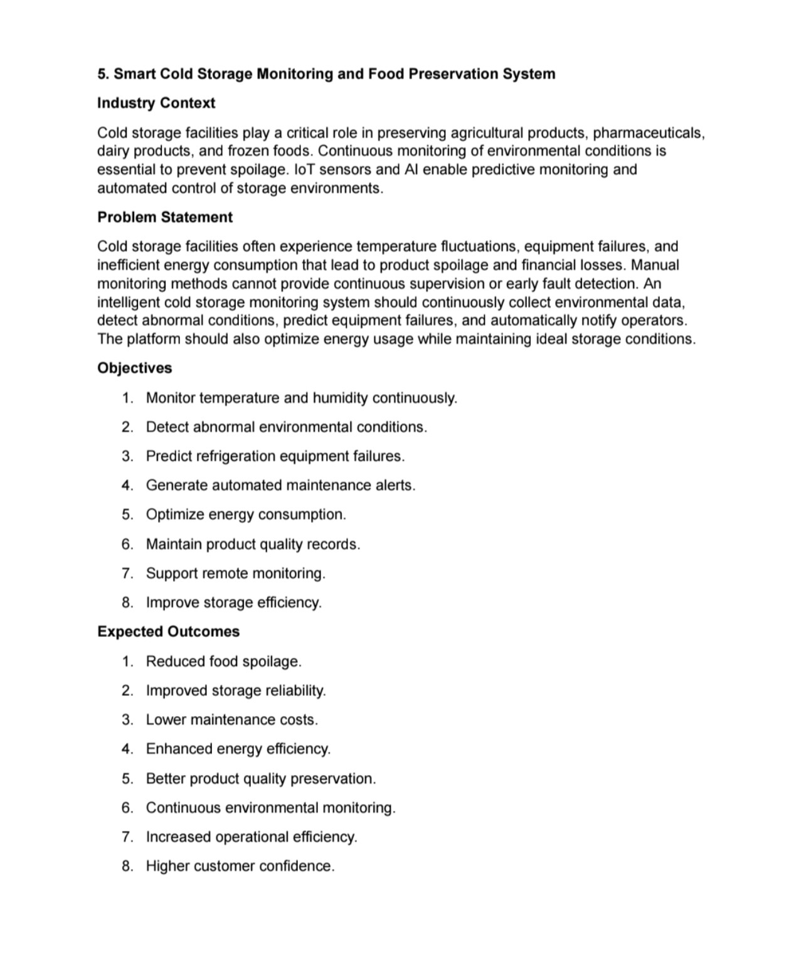
This report is prepared for the assigned Smart Cold Storage Monitoring and Food Preservation System using the Git & Docker Technical Assignment format.

1. Problem Analysis
1.1 Problem Statement
Cold storage facilities preserve agricultural products, pharmaceuticals, dairy products and frozen foods. Temperature fluctuations, refrigeration failures and inefficient energy consumption can cause spoilage and financial loss. Manual monitoring cannot provide continuous supervision or early fault detection.
The proposed system uses IoT sensors and software monitoring to continuously collect temperature and humidity information, identify abnormal conditions, support prediction of refrigeration equipment failures, generate maintenance alerts and improve energy efficiency.
1.2 Objectives
• Continuous temperature and humidity monitoring.
• Detection of abnormal environmental conditions.
• Prediction of refrigeration equipment failures.
• Automated maintenance alerts.
• Energy-consumption optimization.
• Product-quality record maintenance.
• Remote monitoring.
• Improved storage efficiency.
1.3 Functional Requirements
ID | Requirement | Description
FR1 | Sensor Monitoring | Collect temperature and humidity readings.
FR2 | Data Logging | Store timestamped environmental records.
FR3 | Condition Detection | Identify readings outside safe ranges.
FR4 | Alert System | Notify operators about abnormal conditions.
FR5 | Equipment Monitoring | Track refrigeration indicators.
FR6 | Predictive Maintenance | Analyze historical data for failure risk.
FR7 | Energy Monitoring | Record energy usage.
FR8 | Remote Dashboard | Display current and historical status.
1.4 Expected Outcomes
The expected outcomes are reduced spoilage, improved reliability, lower maintenance cost, better energy efficiency, improved product preservation, continuous monitoring, increased operational efficiency and higher customer confidence.

2. Project Structure Design
2.1 Repository Structure
Folder/File | Purpose
cold-storage-monitoring/ | Root repository.
docs/ | Documentation and diagrams.
firmware/ | Sensor/controller code.
backend/ | API and business logic.
database/ | Schema and migration files.
analytics/ | Anomaly and prediction modules.
dashboard/ | Web/mobile interface.
tests/ | Testing files.
screenshots/ | Assessment evidence.
Dockerfile | Application container build instructions.
docker-compose.yml | Multi-container configuration.
.gitignore | Ignored files and secrets.
README.md | Setup and usage guide.
2.2 Justification
The structure separates hardware, application, database, analytics, interface and testing. This improves maintainability and allows different developers to work on separate components. Docker configuration is kept at the project root so the complete application environment can be reproduced easily.
2.3 Naming Practices
• Use descriptive names.
• Keep naming consistent.
• Avoid temporary filenames.
• Do not commit credentials.
• Keep documentation updated.
2.4 Architecture
Sensor Layer → Controller/Edge Device → Backend API → Database → Analytics and Alert Layer → Dashboard. Docker can package the backend, database and supporting services into reproducible environments.

3. Git Repository Initialization
3.1 Initialization Steps
1. Create the project directory.
2. Run git init.
3. Create .gitignore.
4. Run git status.
5. Stage files using git add.
6. Create the first commit.
7. Add the remote repository.
8. Push the project to the remote repository.
3.2 Essential Git Items
Item | Purpose
.git/ | Git metadata and history.
.gitignore | Excludes unwanted or sensitive files.
README.md | Project overview and setup.
git init | Initializes repository.
git status | Shows working-tree status.
git add | Stages changes.
git commit | Creates a version snapshot.
git branch | Manages branches.
git merge | Combines branches.
git pull | Gets remote changes.
git push | Uploads local commits.
3.3 Importance
Git provides version history, collaboration, rollback and controlled integration. It is useful for coordinating firmware, backend, dashboard and Docker development.

4. Git Branching Strategy
4.1 Proposed Model
Branch | Purpose | Example
main | Stable tested version. | main
development | Integration branch. | development
feature | Individual functionality. | feature/sensor-monitoring
feature | Alert module. | feature/alerts
feature | Docker work. | feature/docker
hotfix | Urgent stable-version fix. | hotfix/alert-error
4.2 Workflow
Create a feature branch from development → implement the feature → commit changes → push the branch → review and merge into development → test the integrated system → merge the stable version into main.
4.3 Justification
• Keeps main stable.
• Supports parallel development.
• Makes changes easier to review.
• Reduces unfinished code in production.
• Supports controlled releases and rollback.
4.4 Conflict Resolution
When two branches change the same lines, Git reports a conflict. The developer should inspect the conflict, select the correct combined content, test the result, stage the resolved file and complete the merge.

5. Version Control Workflow and Commit History
5.1 Meaningful Commits
Step | Example Commit | Purpose
1 | Initialize cold storage project | Initial version.
2 | Add sensor monitoring module | Adds data collection.
3 | Create database schema | Adds data storage.
4 | Implement abnormal alerts | Adds notifications.
5 | Add monitoring dashboard | Adds remote display.
6 | Add Dockerfile | Containerizes application.
7 | Add Docker Compose configuration | Defines services.
8 | Add system tests | Adds validation.
9 | Update README setup guide | Improves documentation.
5.2 Good Commit Practices
• Use clear action-oriented messages.
• Keep one logical change per commit.
• Avoid vague messages such as update or final.
• Commit after meaningful functionality.
• Keep commits reviewable.
5.3 Synchronization
Before pushing, update the local branch, inspect changes, run relevant tests and then push. This keeps local and remote repositories synchronized.
5.4 Evidence
• git status screenshot.
• Branch-list screenshot.
• git log screenshot.
• Merge/pull-request screenshot.
• Push/pull evidence.

6. Docker Environment Design
6.1 Why Docker
Docker is suitable because the system contains multiple software components that must work together. Containers provide a repeatable runtime environment and reduce differences between development and deployment systems.
6.2 Components
• Backend/API.
• Database.
• Analytics or prediction service.
• Dashboard service, when separately hosted.
• Supporting services.
6.3 Container Architecture
A practical environment can contain an application container, database container and optional analytics container. Services communicate through a Docker network, while database information is persisted through a volume.
6.4 Environment Variables
Variable | Purpose
DB_HOST | Database hostname.
DB_PORT | Database port.
DB_NAME | Database name.
DB_USER | Database username.
DB_PASSWORD | Database password.
API_PORT | Application port.
ALERT_THRESHOLD | Environmental threshold.
Passwords and keys should not be hard-coded or committed to Git.

7. Dockerfile Development
7.1 Sample Dockerfile
FROM python:3.12-slim
WORKDIR /app
COPY requirements.txt .
RUN pip install --no-cache-dir -r requirements.txt
COPY . .
EXPOSE 8000
CMD ["python", "app.py"]
7.2 Instruction Explanation
Instruction | Purpose
FROM | Selects the base runtime image.
WORKDIR | Sets the container working directory.
COPY | Copies files into the image.
RUN | Installs dependencies.
EXPOSE | Documents the application port.
CMD | Starts the application.
7.3 Build and Run
1. Build using docker build -t cold-storage-app .
2. Run using docker run -p 8000:8000 cold-storage-app.
3. Open the configured application/API port.
4. Use docker logs for troubleshooting.
7.4 Benefits
• Consistent runtime.
• Easy packaging.
• Service isolation.
• Simplified dependencies.
• Portable deployment.

8. Docker Compose Design
8.1 Sample docker-compose.yml
services:
app:
build: .
ports:
- "8000:8000"
environment:
DB_HOST: db
DB_NAME: cold_storage
DB_USER: appuser
DB_PASSWORD: apppass
depends_on:
- db
db:
image: mysql:8.0
environment:
MYSQL_DATABASE: cold_storage
MYSQL_USER: appuser
MYSQL_PASSWORD: apppass
MYSQL_ROOT_PASSWORD: rootpass
volumes:
- db_data:/var/lib/mysql
volumes:
db_data:
8.2 Components
Component | Explanation
app | Runs the cold-storage application.
db | Runs the database.
ports | Maps application port.
environment | Provides configuration.
depends_on | Expresses service dependency.
volumes | Persists database data.
network | Allows service communication.
8.3 Execution
1. Place Dockerfile and compose file in the project root.
2. Run docker compose build.
3. Run docker compose up -d.
4. Check docker compose ps.
5. Inspect docker compose logs.
6. Stop using docker compose down.
The exact image, port, application command and environment values should be changed to match the implemented project.

9. Container Deployment and Testing
ID | Test | Action | Expected Result
TC01 | Build image | docker build | Image builds successfully.
TC02 | Start services | docker compose up -d | Containers run.
TC03 | Application access | Open configured port | Application responds.
TC04 | Database connection | Perform DB operation | Data stored/retrieved.
TC05 | Sensor data | Send valid reading | Reading accepted.
TC06 | Abnormal value | Send unsafe value | Alert generated.
TC07 | Restart | Restart container | Application recovers and data remains.
10. Benefits of Git and Docker
• Git supports collaboration and version history.
• Branches isolate features.
• Docker provides consistent environments.
• Compose simplifies multi-service execution.
• Containerization improves portability.
• Together they improve maintainability and deployment repeatability.
11. Challenges and Improvements
• Sensor communication failures.
• Database/network interruptions.
• Git merge conflicts.
• Dependency and image updates.
• Secure environment configuration.
• Automated CI/CD.
• Container health checks and restart policies.
• Centralized logging and monitoring.
12. Conclusion
Git and Docker provide a practical software-engineering foundation for the Smart Cold Storage Monitoring and Food Preservation System. Git manages source-code history and collaboration, while Docker packages the application and its dependencies into reproducible environments. Docker Compose simplifies execution of the application and database together.
The final submission should include the student's actual Git screenshots, Docker execution screenshots, architecture/workflow diagrams and test evidence as required by the assessment.

